5



### PROJECT REPORT

ON

**“TRAVEL MANAGER”**

## Submitted To: Submitted By:

Ms. Anita Narwal Abhimanyu Raj (23CSE03)

(Assistant Professor) Arpit Awasthi (23CSE37)

Garvit Upadhyay(23CSE56)

### DEPARTMENT OF COMPUTER SCIENCE AND ENGINEERING ARAVALI COLLEGE OF ENGINEERING AND MANAGEMENT FARIDABAD – 121002

Nov-2024

**ACKNOWLEDGEMENT**

This project would not have taken shape, without the guidance provided by **Ms. Anita Narwal**, our mentor who helped us in our project for their invaluable guidance and support throughout the development and resolved all the technical problems related to our project and provided us all the academic, and conceptual support for our Project.

We would also like to thank our project supervisor **Ms. Anita Narwal** who gave me the opportunity and provided us all the academic and conceptual support for our project.

Above all we wish to express our heartfelt gratitude to **Ms. Sakshi Kumar**, H.O.D, CSE

DEPARTMENT whose support has greatly boosted our self-confidence and will go a long way

on helping us to reach further milestones and greater heights.

# **ABSTRACT**

The "Travel Manager" website is an interactive platform project presents the development of a comprehensive web-based Travel Management System designed to streamline and travel planning processes. The system addresses the growing need for centralized travel management solutions in where all the services are present together for user. By implementing modern web technologies like HTML and CSS for the frontend. Special emphasis has been placed on user experience design, implementing responsive interfaces that function seamlessly across desktop and mobile device. Built with HTML and CSS. the website features a user-friendly layout that adapts to various devices, allowing users to book hotels, flights, cruises, airport cabs, etc. seamlessly. This report outlines the project's objectives, core features, and development process, along with future enhancement possibilities.

# **TABLE OF CONTENTS**

**1.INTRODUCTION**

1.1 Problem Statement  
1.2 Objective of the Proposed System  
1.3 Scope of the Proposed Project  
1.4 Feasibility Study  
1.4.1 Technical Feasibility  
1.4.2 Economic Feasibility  
1.4.3 Operational Feasibility

**2.SYSTEM ANALYSIS**

2.1 User Interface

2.2 Hardware Requirements

2.3 Software Requirements

2.4 Communication Interface

2.5 Data Flow Diagram (DFD)

**3.SYSTEM IMPLEMENTATION**

3.1 System Coding

Homepage

Hotel booking page

Cruise booking page

Flight booking page

Cab booking page

Our contact page

**4.SUMMARY AND CONCLUSIONS**  
4.1 Limitations of the System  
4.2 Conclusion  
4.3 Future Enhancement

**5.REFERENCES**

# **INTRODUCTION**

The travel manager is a website that will cater to a wide range of users, from solo adventurers to large groups. By leveraging cutting-edge technology and partnerships with leading travel providers, our platform will simplify the entire travel process, from the initial spark of inspiration to the final moments of a trip. This comprehensive online platform is designed to be the ultimate travel companion, seamlessly integrating various aspects of trip planning, booking, and management and to create a responsive, user-friendly website where customers to book hotels, flights, cruises, airport cabs, etc. we seek to reduce stress, save time, and ultimately make travel more enjoyable and accessible for everyone.

The website employs HTML and CSS deliver an interactive and visually appealing experience. This report outlines the project's objectives, design principles, technical approaches, and challenges, providing insights into the development process and future enhancement possibilities.

## 1.1 PROBLEM STATEMENT

In today’s fast-paced world, there is a need for a centralized, user-friendly travel management platform as products lack an intuitive, user-friendly design and often fail to adapt to various devices, resulting in a frustrating user experience.

We chose this project because of the growing demand for a dedicated, accessible platform for booking and planning of your trips.

## 1.2 OBJECTIVE OF PROPOSED SYSTEM

* It allows travel planning and organizing service.
* To facilitate an intuitive and easy-to-navigate website design.
* It allows Integrated booking services for flights, accommodations, transportation, and activities.
* It gives personalized recommendations based on user preferences and past trips.
* It gives Collaborative tools for group travel planning.
* It gives Live updates on travel conditions, alerts, and local information, local news.
* It gives Mobile compatibility for on-the-go access and updates.
* To Integrate flight, hotel, and car rental booking services.
* Multiple channels for customer support like chat, email, phone, etc.

.

## 1.3 SCOPE OF THE PROPOSED PROJECT

Through Travel Manager, people can book hotels, cruises, cabs, etc. through a single centralized website which will control costs, and implement sustainable travel policies.

It will help people in choosing the best travel destinations and transportation for themselves at low-cost. It is a secure process and beneficial. It reduces time and effort in planning trips. It will help in tourism activities of regions and location creating economic activity.

## 1.4 FEASIBILITY STUDY

The feasibility study is an essential process to evaluate the viability of the "Travel manager" website project. Over a period of time, we assessed various factors to determine the project's worthiness. This study provided valuable insights that guided our decisions on software selection, hardware requirements, and overall project direction.

**Technical Feasibility**: Evaluated the technical resources required for the development, including the use of HTML and CSS, ensuring that the technology stack aligns with our project goals.

**Economic Feasibility**: Analysed the potential costs and financial benefits associated with the project, confirming that the investment that we put in development would yield a favourable return by meeting the growing need of the people.

**Operational Feasibility**: Assessed the operational aspects of the project, ensuring that the website would enhance user engagement as currently the tourism industry is booming ultimately improving customer satisfaction.

##### **TECHNICAL FEASIBILITY**

The technical feasibility of the "Travel Manager" website assesses whether the project can be successfully implemented using the available technology and resources. The proposed system is technically viable as it utilizes standard web technologies such as HTML and CSS. This ensures compatibility across various devices and platforms.

Additionally, the responsive design guarantees accessibility on both desktop and mobile devices, catering to a wide user base. Given the simplicity of the technical requirements and the availability of skilled personnel proficient in these technologies, the project is deemed technically feasible.

##### **ECONOMIC FEASIBILITY**

Economic feasibility assesses whether the benefits of developing the "Travel manager" website justify the associated costs. Conducting a cost-benefit analysis indicates that the potential revenue from booking commissions produce outweigh the initial investment required for development. The costs associated with the project can be categorized based on the phases of implementation, which include:

**Personnel Costs**: Expenses for developers, designers, and consultants involved in the project.

**Computer Costs**: Costs for any hardware used during development, testing, including workstations, etc.

**New Software and Equipment Costs**: Costs incurred for purchasing or upgrading any software necessary for hosting and managing the website.

At last we can conclude that, the development costs are manageable and are expected to be made back quickly through user engagement making the project economically viable.

##### **OPERATIONAL FEASIBILITY**

The operational feasibility of the "Travel Manager" website is high, as it addresses the urgent need for a centralized platform for booking flights, hotels, cabs, cruises, etc. The system is designed for user-friendly navigation and efficient order processing, ensuring that customers can easily browse and book trips. The early beta testing will help us in gathering User feedback that will confirm the website does its intended use and meets customer expectations, enhancing engagement. Overall, the website will significantly improve customer engagements and satisfaction in the online travel services market.

**2.LITERATURE REVIEW**

#### 2.1 Web Development

The development of the website is done by using modern web development principles to ensure functionality, responsiveness, and user engagement. Any should be visually appealing, accessible, and easy to use such that it takes the users attention.

Responsive web design is a crucial approach in modern website development that ensures a website's layout and content adapt seamlessly to various screen sizes and resolutions, implementing responsive design was essential to provide a consistent user experience across devices such as desktops, tablets, and smartphones.

The website employs CSS media queries to adjust the layout dynamically based on the screen width. improving readability and navigation on compact devices.

Responsive web design enhances accessibility and ensures that users can comfortably browse and book tickets regardless of the device they use.

#### 2.1.1 Front-End Technologies

The website uses front-end technologies such as HTML and CSS to deliver an interactive and responsive website. These technologies were chosen for their flexibility, compatibility, and ability to meet the project's design and functionality goals.

* **HTML (Hyper Text Markup Language):** HTML stands for Hypertext Markup Language. It is the standard language for creating web pages and web applications. HTML uses tags to define the structure and content of a webpage, including text, images, links, and other elements. It forms the backbone of most websites.
* **CSS (Cascading Style Sheets):** It is a styling language used to describe the presentation of HTML documents. CSS controls the layout, colours, fonts, and overall visual appearance of web pages. It allows developers to separate design from content, making websites more maintainable and consistent across different pages and devices.

#### 2.1.2 User Experience (UX) Design

User Experience (UX) design is a main element that is to be considered in the development of the "Travel Manager" website, ensuring that users have a seamless and enjoying a visually appealing interface. The focus was placed on intuitive navigation and a structured layout to enhance usability and engagement.

**2.1.3 Navigation Design**

Navigation plays a critical role in guiding users through a website, especially for platforms like "Travel Manager," which features multiple sections such as hotel booking, home cruises, flights etc. The website employs a responsive navigation bar that adapts to various screen sizes, ensuring seamless access across devices.

**2.1.4 Interaction and Responsive website**

Interaction in a website is what keeps the user engaged and it is a important aspect of modern web design, enhancing user engagement and creating a memorable experience. The "Travel Manager" website integrates interactive elements to make navigation simple and appalling to the user and visually appealing while maintaining a sleek, clean look and feel.

Responsive website is important in modern website development that ensures a website's layout and content adapt seamlessly to various screen sizes and resolutions. For "Travel Manager," implementing responsive design was essential to provide a consistent user experience across devices such as desktops, tablets, and smartphones as users may connect or use different devices to use the website.

**2.1.5 Search Engine Optimization (SEO) and Accessibility**

A successful website not only provides a great user experience but also ensures visibility on search engines and inclusivity for all users. The website incorporates best practices in SEO and accessibility to enhance its reach and usability. It is essential for increasing a website's visibility and ranking on search engines like Google in turn it increases website traffic and engagements.

#### 3. System Design

The website is designed as a modular system with different pages and each having their own functionalities. Each webpage represents a different feature of the website, contributing to a cohesive and user-friendly experience. The system is divided into distinct components to facilitate usability.

**3.1 System Functionality**

The "Travel Manager" website is designed to provide users with a seamless experience for planning their travel journeys. Its functionality focuses on delivering a user-centric approach, ensuring responsiveness, and interactivity. The homepage acts as a gateway to the website, offering a brief introduction to the functionality and linking to other pages like hotel bookings, flights, cruises, cabs, and our Contact. The navigation bar, present on every page, ensures that users can effortlessly move between sections without confusion.

The booking system is critical component of the website’s functionality. It simplifies the process of booking a service as we have different sections for different services so it creates. The booking form is designed to be intuitive, requiring minimal inputs while ensuring accuracy.

The website’s responsive design ensures that it adapts to various devices, offering an optimal experience for desktop, tablet, and mobile users alike. This adaptability is achieved through CSS media queries, which dynamically adjust the layout and navigation elements based on screen size. Accessibility is another critical aspect.

By combining simple navigation, clear categorization, a streamlined user interface , and responsive design, the "Travel Manager" website delivers a highly functional platform to its users. Every feature is crafted to enhance usability, engagement, and accessibility, making the website your first choice for ticket booking, trip planning and other e-tourism services.

**3.2 system modules**

The system is structured into the following modules, each implemented as separate HTML pages and supported by shared CSS and JavaScript files:

1. 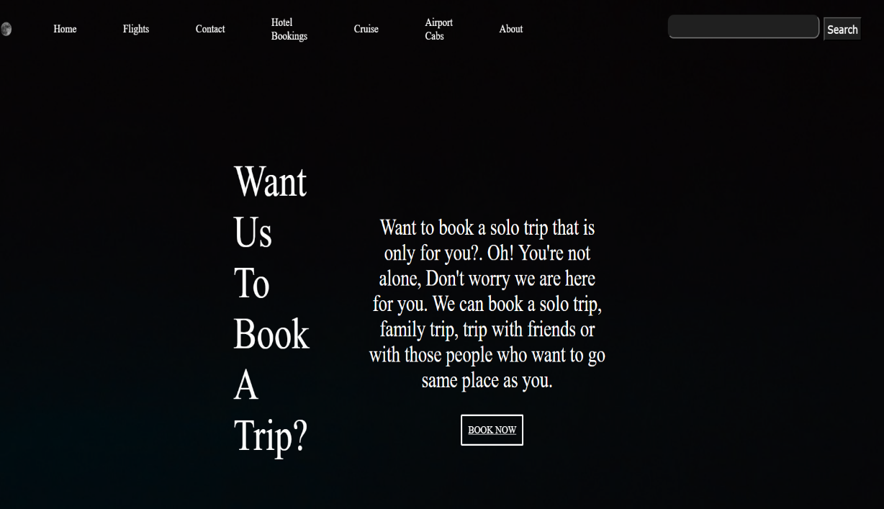**Homepage Module**: Displays an introduction to the website and links to all other modules via the navigation bar.
2. 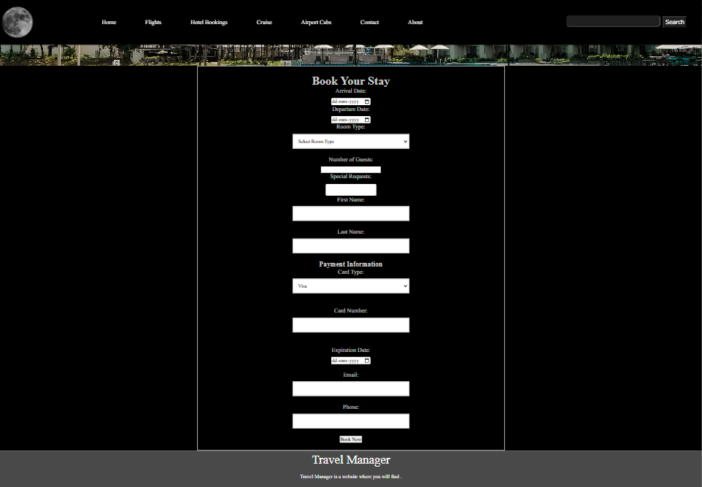**Hotel Booking Module**:
3. To create an intuitive interface for hotel reservations.
4. To ensure all necessary booking information is collected efficiently.
5. To provide a seamless user experience from navigation to booking confirmation.
6. To streamline the process of booking hotels for stays.
7. 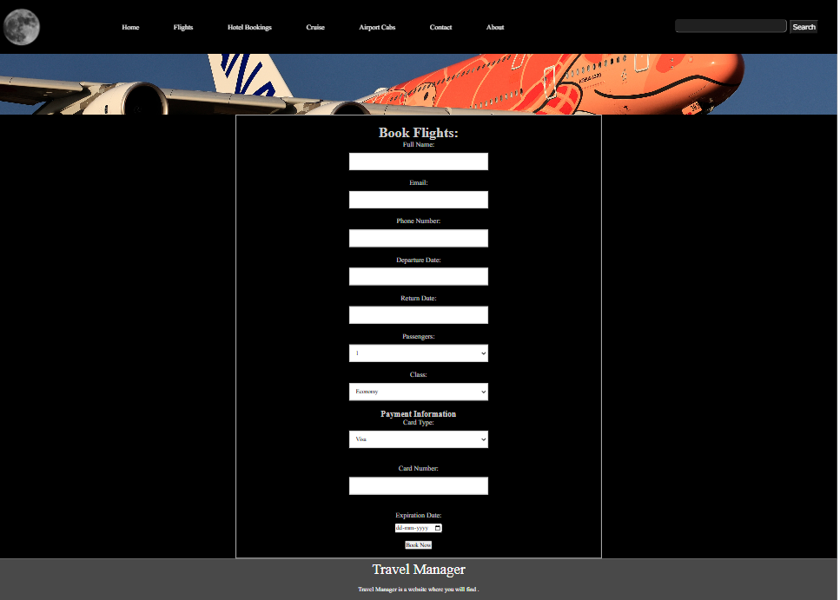 **Flights Booking Module**:
8. To create an intuitive interface for flight reservations.
9. To ensure all necessary booking information is collected efficiently.
10. To provide a seamless user experience from navigation to booking confirmation.
11. To streamline the process of booking flights for travel.
12. 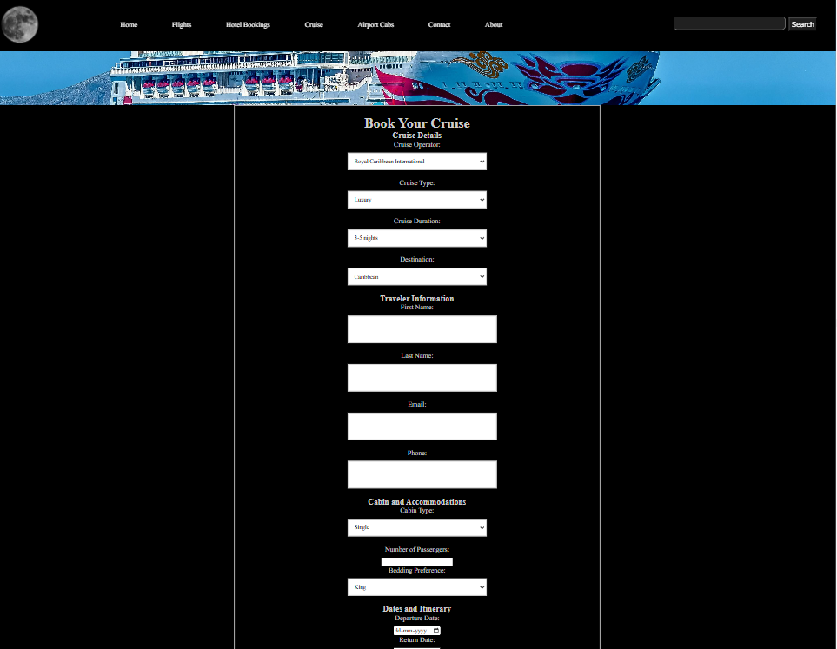**Cruise Booking Module**:
13. To create an intuitive interface for cruise reservations.
14. To ensure all necessary booking information is collected efficiently.
15. To provide a seamless user experience from navigation to booking confirmation.
16. To streamline the process of booking cruises for both travel and private vacations.
17. **Airport Cabs Booking Module**: 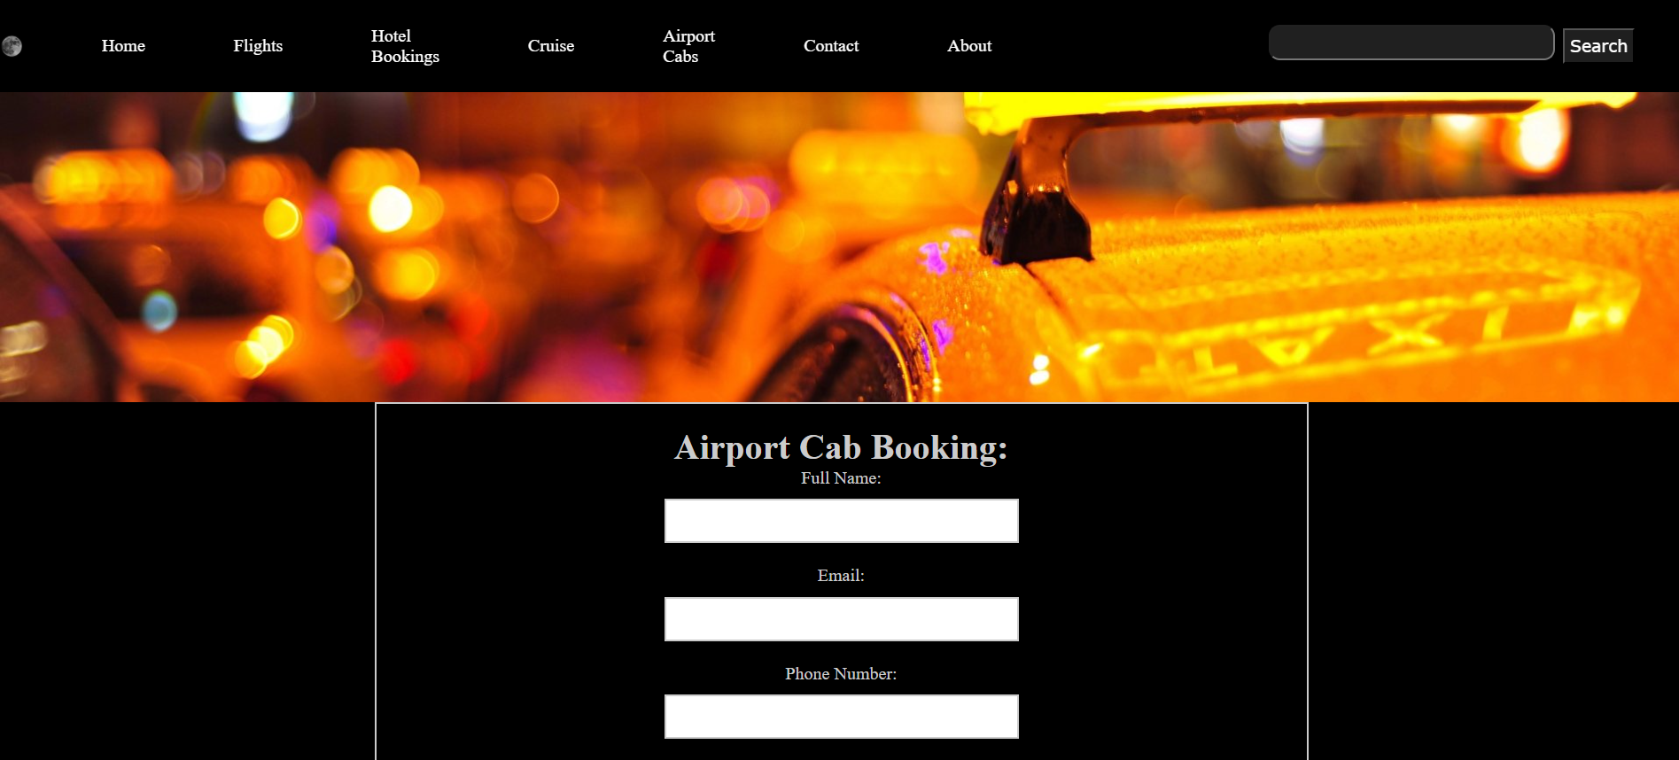

• To create an intuitive interface for cab reservations specifically for airport pickups.

• To ensure all necessary booking information is collected efficiently.

• To provide a seamless user experience from navigation to booking confirmation.

• To streamline the process of booking cabs for airport pickups and drop-offs at the destination.

1. **Contact Module**: 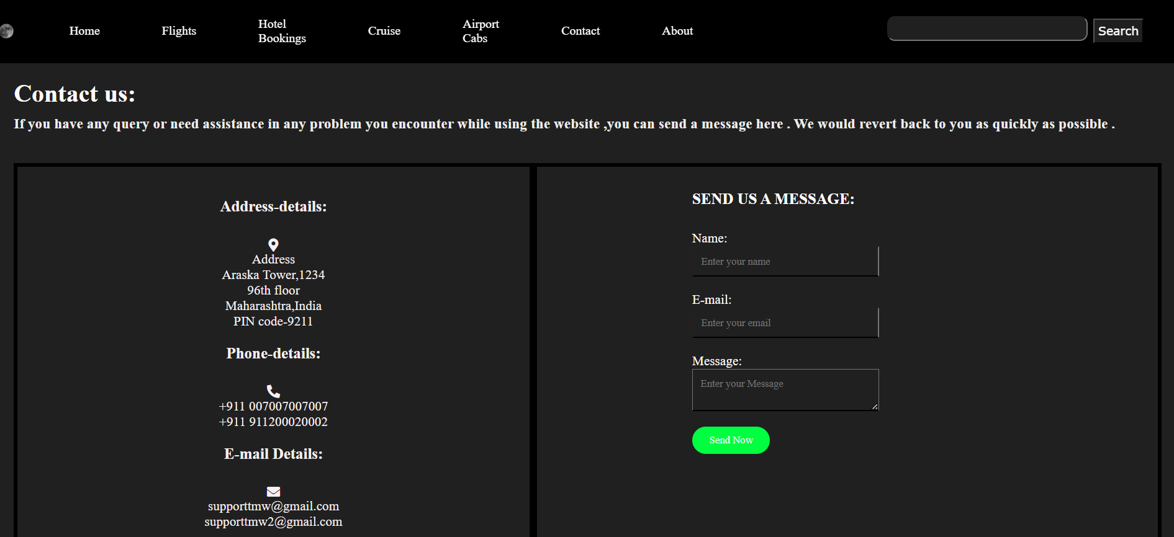
2. **About Us Module**

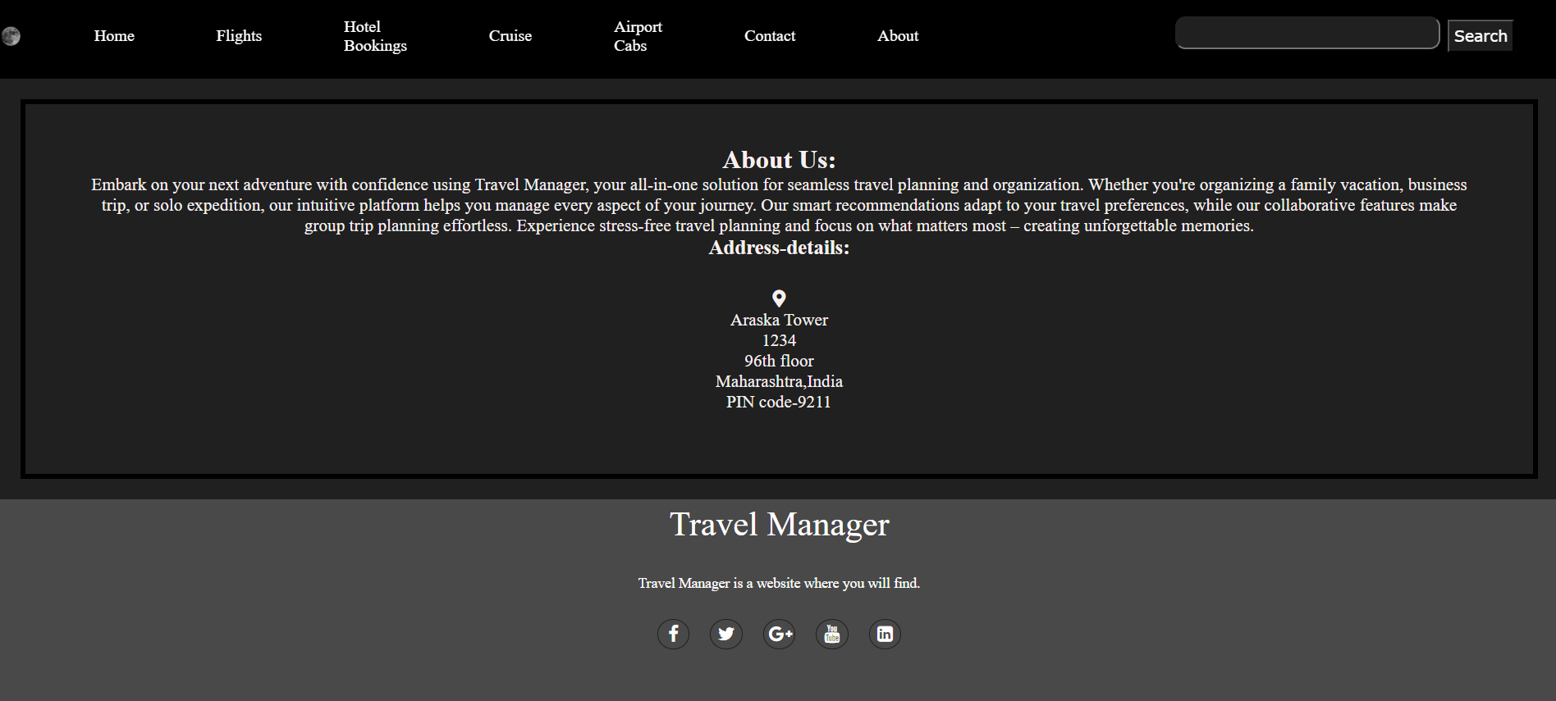

**3.5 System Diagram**

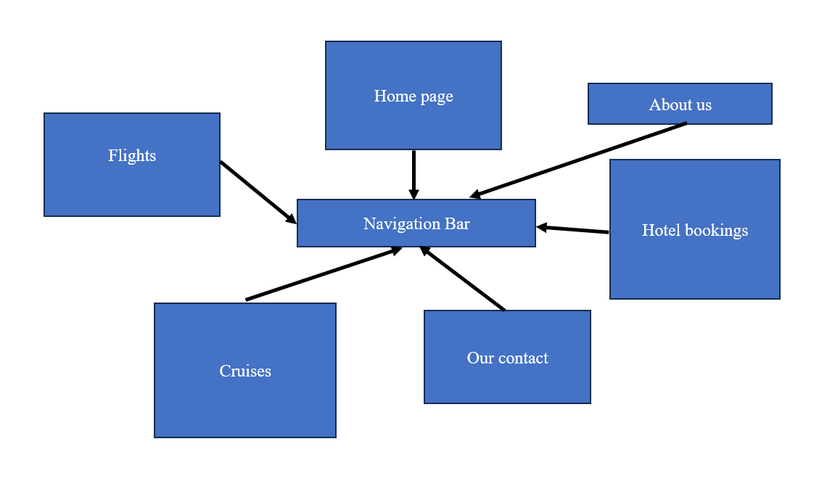

## 2 SYSTEM ANALYSIS

**2.1 USER INTERFACE**

* Front-end software: HTML, CSS, JavaScript

### **HARDWARE REQUIREMENTS**

* Pentium IV or higher, (PIV-300GHz recommended)
* 256 RAM
* 1 Gb hard free drive space.

### **2.3 SOFTWARE REQUIREMENTS**

Following are the software used for Travel Manager:

* + - HTML
    - CSS
    - Visual Studio Code
    - Web Browser: Google Chrome and Mozilla
    - Operating System: Windows 12

### **2.4 COMMUNICATION INTERFACE**

This project supports all types of web browsers.

## 3.SYSTEM IMPLEMENTATION

**3.1 SYSTEM CODING:**

### 1.Homepage

<!DOCTYPE html>

<html lang="en">

   <head>

      <meta charset="UTF=8">

      <meta name="viewport" content="width=device-width",initial scale="1:0">

      <link rel="stylesheet" href="index.css">

      <link rel="stylesheet" href="https://stackpath.bootstrapcdn.com/font-awesome/4.7.0/css/font-awesome.min.css">

   </head>

   <header>

      <nav class="navbar background">

         <ul class="navlinks">

            <div class="logo"><img src="moon.png" alt="logo"></div>

            <li><a href="TravelManager.html">Home</a></li>

            <li><a href="flight.html">Flights</a></li>

            <li><a href="ourcontact.html">Contact</a></li>

            <li><a href="hotel.html">Hotel Bookings</a></li>

            <li><a href="cruise.html">Cruise</a></li>

            <li><a href="cab.html">Airport Cabs</a></li>

            <li><a class="active" href="about.html">About</a></li>

         </ul>

         <div class="rightnav">

            <input type="text" name="search" id="search">

            <button class="btnsm"> Search </button>

         </div>

     </nav>

   </header>

   <body>

      <section class="background container">

         <div class="boxmain">

            <div class="phalf">

               <p class="bigt">

                  Want Us To Book A Trip?

               </p>

               <p class="smallt">

               Want to book a solo trip that is only for you?. Oh! You're not alone, Don't worry we are here for you. We can book a solo trip, family trip, trip with friends or with those people who want to go same place as you.

               </p>

                  <div class="buttons">

                     <button class="btn"><a href=hotel.html>BOOK NOW</a></button>

                  </div>

            </div>

         </div>

      </section>

      <section class="new">

         <div class="paras">

         <p class="valo">KYOTO</p>

         <p class="velo">JAPAN</p>

         </div>

         <div class="seemore">

            <button class="see btn">

               EXPLORE

            </button>

         </div>

         <div class="jp row">

            <div class="column">

            <img src="kyoto3.jpg" alt="kyoto">

            </div>

            <div class="column">

            <img src="kyoto1.jpg" alt="kyoto2">

            </div>

            <div class="column">

               <img src="kyoto4.jpg" alt="kyoto3">

               </div>

         </div>

      </section>

   </body>

   <footer>

      <div class="footer-content">

          <h3>Travel Manager</h3>

          <p>Travel Manager is a  website where you will find .</p>

          <ul class="socials">

              <li><a href="#"><i class="fa fa-facebook"></i></a></li>

              <li><a href="Arpitawasthi"><i class="fa fa-twitter"></i></a></li>

              <li><a href="Arpitawasathi"><i class="fa fa-reddit"></i></a></li>

              <li><a href="#"><i class="fa fa-instagram"></i></a></li>

              <li><a href="#"><i class="fa fa-linkedin-square"></i></a></li>

          </ul>

      </div>

      <div class="footer-bottom background">

          <p>copyright &copy;2024 <a href="#">Travel Manager</a>  </p>

      </div>

   </footer>

</html>

### Styling for Homepage

*{

    padding: 0;

    margin: 0;

}

.background {

    background: rgba(11, 11, 11, 0.7) url(yo.jpg);

    background-size: cover;

    background-blend-mode: darken;

    background-color: black;

}

.body {

    background-color: rgb(249, 247, 247);

    color: white;

    font-size: 20px;

}

.container {

    width: 97.35%;

    margin: 0px auto;

    color: #fefcfc;

    background-color: rgb(32, 32, 32);

    padding: 20px 20px 20px 20px;

}

.logo {

    display: flex;

    width: 20%;

}

.logo img {

    width: 40%;

    border-radius: 200%;

}

.navbar {

    display: flex;

    cursor: pointer;

    top: 0px;

    align-items: center;

    justify-content: center;

    position: sticky;

    top: 0;

}

.navbar ul {

    width: 65%;

    display: flex;

    justify-content: center;

    align-items: center;

}

.navbar ul li {

    list-style: none;

    display: flex;

    padding: 23px 40px;

}

.navbar li a {

    text-decoration: none;

    color: white;

    cursor: pointer;

    transition: transform 0.2s ease, box-shadow 0.2s ease;

}

.navbar li a:hover {

    text-decoration: none;

    transform: scale(1.3);

    box-shadow: 0 5px 15px rgba(0, 0, 0, 0.2);

}

.rightnav {

    width: 35%;

    text-align: right;

    padding: 0px 40px;

    color: black;

}

#search {

    padding: 3px;

    font-size: 20px;

    border-radius: 10px;

    background-color: rgb(32, 32, 32);

    cursor: pointer;

}

#search:hover {

    box-shadow: 0 5px 15px rgba(0, 0, 0, 0.2);

}

.btnsm {

    font-family: Verdana, Geneva, Tahoma, sans-serif;

    padding: 5px;

    font-size: 15px;

    margin: 3px;

    vertical-align: middle;

    color: white;

    background-color: rgb(31, 31, 31);

    cursor: pointer;

}

.background

{

    background: rgba(0, 0, 0, 0.7) url(yo.jpg);

    background-size: cover;

    background-blend-mode: darken;

}

.boxmain

{

    display: flex;

    justify-content: center;

    align-items: center;

    display: flex;

    flex-direction: column;

    margin: auto;

    max-width: 50%;

    padding: 100px;

    margin: auto;

}

.phalf

{

    height: 100%;

    display: flex;

}

.ihalf

{

    width: 30%;

}

.ihalf img

{

    width: 300%;

    border-radius: 200%;

}

.bigt

{

    font-size: 60px;

    padding: 10px;

    color: white;

}

.smallt

{

    display: flex;

    font-size: 30px;

    justify-content: center;

    padding: 80px;

    margin: 10px;

    text-align: center;

    color: white;

}

.buttons

{

    display: flex;

    margin: 10px;

    position: absolute;

    padding: 350px 390px;

}

.btn{

    padding: 10px;

    font-family: 'Times New Roman', Times, serif;

    border-radius: 2px;

    font-size: 15px;

    background: none;

    color: white;

    border: 3px solid white;

    cursor: pointer;

    transition: transform 0.2s ease, box-shadow 0.2s ease;

}

.btn:hover

{

    transform: scale(1.1);

    box-shadow: 0 5px 15px rgba(0, 0, 0, 0.2);

}

.btn a:visited

{

    color: white;

}

.btn a:active

{

    color: red;

}

.valo

{

    font-size: 50px;

    color: white;

}

.velo

{

    font-size: 25px;

    color: white;

}

.new

{

    margin: auto;

    display: flex;

    justify-content: space-evenly;

    align-items: center;

    height: 70vh;

    padding: 0px 100px;

    width: 86.79%;

    background-color: rgb(31, 31, 31);

}

.jp

{

    font-size: 20px;

    box-sizing: border-box;

}

.jp img

{

    width: 90%;

    border-radius: 90px 90px 90px 0px;

    display: flex;

    justify-content: left;

    box-sizing: border-box;

    padding: 10px;

}

.see:hover

{

    background-color: transparent;

}

.paras

{

    width: 20%;

    text-align: right;

}

.seemore

{

    width: 30%;

    justify-content: center;

    display: flex;

}

.row

{

    display: flex;

}

.column

{

    flex: 50%;

    display: flex;

    align-items: center;

    justify-content: right;

    cursor: pointer;

}

.footer {

    position: absolute;

    bottom: 0;

    left: 0;

    right: 0;

    background: #ffffff;

    height: auto;

    width: 97.5vw;

    box-sizing: border-box;

    padding-top: 40px;

    color: rgb(31, 31, 31);

}

.footer-content {

    display: flex;

    align-items: center;

    justify-content: center;

    flex-direction: column;

    text-align: center;

    background-color: rgb(73, 73, 73)

}

.footer-content h3 {

    font-size: 2.1rem;

    font-weight: 500;

    text-transform: capitalize;

    line-height: 3rem;

    color: white;

}

.footer-content p {

    width: 550px;

    margin: 10px auto;

    line-height: 28px;

    font-size: 14px;

    color: white;

}

.socials {

    list-style: none;

    display: flex;

    align-items: center;

    justify-content: center;

    margin: 1rem 0 3rem 0;

}

.socials li {

    margin: 0 10px;

}

.socials a {

    text-decoration: none;

    color: white;

    border: 1.1px solid rgb(31, 31, 31);

    padding: 5px;

    border-radius: 50%;

}

.socials a i {

    font-size: 1.1rem;

    width: 20px;

    transition: transform 0.2s ease, box-shadow 0.2s ease;

}

.socials a:hover i {

    color: white;

    transform: scale(1.3);

    box-shadow: 0 5px 15px rgba(0, 0, 0, 0.2);

}

.footer-bottom

{

    background: rgb(73, 73, 73);

    width: 98.9vw;

    padding: 20px;

    padding-bottom: 40px;

    text-align: center;

    padding: 20px 0;

}

.footer-bottom p {

    font-size: 20px;

    word-spacing: 2px;

    text-transform: capitalize;

    text-align: center;

}

.footer-bottom p a {

    color: rgb(49, 23, 220);

    font-size: 16px;

    text-decoration: none;

}

@media (max-width:500px) {

    .footer-menu ul {

        display: flex;

        margin-top: 10px;

        margin-bottom: 20px;

    }

}

### 2.Hotel booking page

### <html>

### <head>

### <link rel="stylesheet" href="hotel.css">

### <link rel="stylesheet" href="https://stackpath.bootstrapcdn.com/font-awesome/4.7.0/css/font-awesome.min.css">

### </head>

### <body>

### <nav class="navbar background">

### <ul class="navlinks">

### <div class="logo"><img src="moon.png" alt="logo"></div>

### <li><a href="TravelManager.html">Home</a></li>

### <li><a href="flight.html">Flights</a></li>

### <li><a href="hotel.html">Hotel Bookings</a></li>

### <li><a href="cruise.html">Cruise</a></li>

### <li><a href="cab.html">Airport Cabs</a></li>

### <li><a href="ourcontact.html">Contact</a></li>

### <li><a class="active" href="about.html">About</a></li>

### </ul>

### <div class="rightnav">

### <input type="text" name="search" id="search">

### <button class="btnsm"> Search </button>

### </div>

### </nav>

### <div class="header-image">

### <img src="hotelkla.jpg" alt="header Image" class="header-image">

### </div>

### <div class="omega">

### <div class="booking-form">

### <div class="form-content">

### <h1>Book Your Stay</h1>

### <div class="form-group">

### <label for="arrival-date">Arrival Date:</label>

### <input type="date" id="arrival-date" name="arrival-date" required>

### </div>

### <div class="form-group">

### <label for="departure-date">Departure Date:</label>

### <input type="date" id="departure-date" name="departure-date" required>

### </div>

### <div class="form-group">

### <label for="room-type">Room Type:</label>

### <select id="room-type" name="room-type" required>

### <option value="">Select Room Type</option>

### <option value="single">Single Room</option>

### <option value="double">Double Room</option>

### <option value="suite">Suite</option>

### </select>

### </div>

### <div class="form-group">

### <label for="number-of-guests">Number of Guests:</label>

### <input type="number" id="number-of-guests" name="number-of-guests" required>

### </div>

### <div class="form-group">

### <label for="special-requests">Special Requests:</label>

### <textarea id="special-requests" name="special-requests"></textarea>

### </div>

### <div class="form-group">

### <label for="first-name">First Name:</label>

### <input type="text" id="first-name" name="first-name" required>

### </div>

### <div class="form-group">

### <label for="last-name">Last Name:</label>

### <input type="text" id="last-name" name="last-name" required>

### </div>

### <section>

### <h3>Payment Information</h3>

### <label for="card-type">Card Type:</label>

### <select id="card-type" name="card-type">

### <option value="visa">Visa</option>

### <option value="mastercard">Mastercard</option>

### <option value="amex">American Express</option>

### </select><br><br>

### <label for="card-number">Card Number:</label>

### <input type="text" id="card-number" name="card-number"><br><br>

### <label for="expiration-date">Expiration Date:</label>

### <input type="date" id="expiration-date" name="expiration-date"><br><br>

### </section>

### <div class="form-group">

### <label for="email">Email:</label>

### <input type="email" id="email" name="email" required>

### </div>

### <div class="form-group">

### <label for="phone">Phone:</label>

### <input type="tel" id="phone" name="phone" required>

### </div>

### <button type="submit">Book Now</button>

### </form>

### 

### </div>

### </div>

### </div>

### </body>

### <footer>

### <div class="footer-content">

### <h3>Travel Manager</h3>

### <p>Travel Manager is a  website where you will find .</p>

### <ul class="socials">

### <li><a href="#"><i class="fa fa-facebook"></i></a></li>

### <li><a href="#"><i class="fa fa-twitter"></i></a></li>

### <li><a href="#"><i class="fa fa-reddit"></i></a></li>

### <li><a href="#"><i class="fa fa-instagram"></i></a></li>

### <li><a href="#"><i class="fa fa-linkedin-square"></i></a></li>

### </ul>

### </div>

### <div class="footer-bottom">

### 

### 3. Our Contact page

<html>

    <head>

         <meta charset="UTF=8">

        <meta name="viewport" content="width=device-width",initial scale="1:0">

        <link rel="stylesheet" href="ourcontact.css">

        <link rel="stylesheet" href="https://cdnjs.cloudflare.com/ajax/libs/font-awesome/5.15.4/css/all.min.css">

        <link rel="stylesheet" href="https://stackpath.bootstrapcdn.com/font-awesome/4.7.0/css/font-awesome.min.css">

    </head>

    <body>

        <nav class="navbar background">

            <ul class="navlinks">

               <div class="logo"><img src="moon.png" alt="logo"></div>

               <li><a href="TravelManager.html">Home</a></li>

                <li><a href="flight.html">Flights</a></li>

                <li><a href="hotel.html">Hotel Bookings</a></li>

                <li><a href="cruise.html">Cruise</a></li>

                <li><a href="cab.html">Airport Cabs</a></li>

                <li><a href="ourcontact.html">Contact</a></li>

                <li><a class="active" href="about.html">About</a></li>

            </ul>

            <div class="rightnav">

               <input type="text" name="search" id="search">

               <button class="btnsm"> Search </button>

            </div>

        </nav>

        <div class="container">

            <h1>Contact us:</h1>

            <h3><p>If you have any query or need assistance in any problem you encounter while using the website ,you can send a message here . We would revert back to you as quickly as possible .</p></h3>

            <div class="content">

                <div class="content-left">

                    <h3>Address-details:</h3><br>

                        <i class="fas fa-map-marker-alt"></i>

                        <div class="details">Address</div>

                        <div class="text-one">Araska Tower,1234</div>

                        <div class="text-two">96th floor<br>Maharashtra,India<br>PIN code-9211</div><br>

                    <h3>Phone-details:</h3><br>

                        <i class="fas fa-phone-alt"></i>

                        <div class="details"></div>

                        <div class="text-one">+911 007007007007</div>

                        <div class="text-two">+911 911200020002</div>

                        <br>

                    <h3>E-mail Details:</h3><br>

                        <i class="fas fa-envelope"></i>

                        <div class="details"></div>

                        <div class="text-one">supporttmw@gmail.com</div>

                        <div class="text-two">supporttmw2@gmail.com</div>

                </div>

                <div class="content-right">

                    <div class="input-row">

                    <div class="omega">

                    <form action="#">

                        <h3>SEND US A MESSAGE:</h3><br>

                        <div class="input-box">

                            <label for="name">Name:</label>

                            <input type="text" id="name" placeholder="Enter your name">

                        </div>

                        <div class="input-box">

                            <label for="email">E-mail:</label>

                            <input type="email" id="email" placeholder="Enter your email">

                        </div>

                        <div class="input-box">

                            <label for="message"> Message:</label>

                            <textarea id="message" placeholder="Enter your Message"></textarea>

                        </div>

                        <div class="button">

                            <input type="submit" value="Send Now">

                        </div>

                    </form>

                    </div>

                    </div>

                </div>

            </div>

        </div>

    </body>

    <footer>

        <div class="footer-content">

            <h3>Travel Manager</h3>

            <p>Travel Manager is a  website where you will find .</p>

            <ul class="socials">

                <li><a href="#"><i class="fa fa-facebook"></i></a></li>

                <li><a href="#"><i class="fa fa-twitter"></i></a></li>

                <li><a href="#"><i class="fa fa-reddit"></i></a></li>

                <li><a href="fr-abhimanyu"><i class="fa fa-instagram"></i></a></li>

                <li><a href="fr-abhimanyu"><i class="fa fa-linkedin-square"></i></a></li>

            </ul>

        </div>

        <div class="footer-bottom">

            <p>copyright &copy;2024 <a href="#">Travel Manager</a>  </p>

        </div>

    </footer>

</html>

<html>

    <head>

         <meta charset="UTF=8">

        <meta name="viewport" content="width=device-width",initial scale="1:0">

        <link rel="stylesheet" href="ourcontact.css">

        <link rel="stylesheet" href="https://cdnjs.cloudflare.com/ajax/libs/font-awesome/5.15.4/css/all.min.css">

        <link rel="stylesheet" href="https://stackpath.bootstrapcdn.com/font-awesome/4.7.0/css/font-awesome.min.css">

    </head>

    <body>

        <nav class="navbar background">

            <ul class="navlinks">

               <div class="logo"><img src="moon.png" alt="logo"></div>

               <li><a href="TravelManager.html">Home</a></li>

                <li><a href="flight.html">Flights</a></li>

                <li><a href="hotel.html">Hotel Bookings</a></li>

                <li><a href="cruise.html">Cruise</a></li>

                <li><a href="cab.html">Airport Cabs</a></li>

                <li><a href="ourcontact.html">Contact</a></li>

                <li><a class="active" href="about.html">About</a></li>

            </ul>

            <div class="rightnav">

               <input type="text" name="search" id="search">

               <button class="btnsm"> Search </button>

            </div>

        </nav>

        <div class="container">

            <h1>Contact us:</h1>

            <h3><p>If you have any query or need assistance in any problem you encounter while using the website ,you can send a message here . We would revert back to you as quickly as possible .</p></h3>

            <div class="content">

                <div class="content-left">

                    <h3>Address-details:</h3><br>

                        <i class="fas fa-map-marker-alt"></i>

                        <div class="details">Address</div>

                        <div class="text-one">Araska Tower,1234</div>

                        <div class="text-two">96th floor<br>Maharashtra,India<br>PIN code-9211</div><br>

                    <h3>Phone-details:</h3><br>

                        <i class="fas fa-phone-alt"></i>

                        <div class="details"></div>

                        <div class="text-one">+911 007007007007</div>

                        <div class="text-two">+911 911200020002</div>

                        <br>

                    <h3>E-mail Details:</h3><br>

                        <i class="fas fa-envelope"></i>

                        <div class="details"></div>

                        <div class="text-one">supporttmw@gmail.com</div>

                        <div class="text-two">supporttmw2@gmail.com</div>

                </div>

                <div class="content-right">

                    <div class="input-row">

                    <div class="omega">

                    <form action="#">

                        <h3>SEND US A MESSAGE:</h3><br>

                        <div class="input-box">

                            <label for="name">Name:</label>

                            <input type="text" id="name" placeholder="Enter your name">

                        </div>

                        <div class="input-box">

                            <label for="email">E-mail:</label>

                            <input type="email" id="email" placeholder="Enter your email">

                        </div>

                        <div class="input-box">

                            <label for="message"> Message:</label>

                            <textarea id="message" placeholder="Enter your Message"></textarea>

                        </div>

                        <div class="button">

                            <input type="submit" value="Send Now">

                        </div>

                    </form>

                    </div>

                    </div>

                </div>

            </div>

        </div>

    </body>

    <footer>

        <div class="footer-content">

            <h3>Travel Manager</h3>

            <p>Travel Manager is a  website where you will find .</p>

            <ul class="socials">

                <li><a href="#"><i class="fa fa-facebook"></i></a></li>

                <li><a href="#"><i class="fa fa-twitter"></i></a></li>

                <li><a href="#"><i class="fa fa-reddit"></i></a></li>

                <li><a href="fr-abhimanyu"><i class="fa fa-instagram"></i></a></li>

                <li><a href="fr-abhimanyu"><i class="fa fa-linkedin-square"></i></a></li>

            </ul>

        </div>

        <div class="footer-bottom">

            <p>copyright &copy;2024 <a href="#">Travel Manager</a>  </p>

        </div>

    </footer>

</html>

<html>

    <head>

         <meta charset="UTF=8">

        <meta name="viewport" content="width=device-width",initial scale="1:0">

        <link rel="stylesheet" href="ourcontact.css">

        <link rel="stylesheet" href="https://cdnjs.cloudflare.com/ajax/libs/font-awesome/5.15.4/css/all.min.css">

        <link rel="stylesheet" href="https://stackpath.bootstrapcdn.com/font-awesome/4.7.0/css/font-awesome.min.css">

    </head>

    <body>

        <nav class="navbar background">

            <ul class="navlinks">

               <div class="logo"><img src="moon.png" alt="logo"></div>

               <li><a href="TravelManager.html">Home</a></li>

                <li><a href="flight.html">Flights</a></li>

                <li><a href="hotel.html">Hotel Bookings</a></li>

                <li><a href="cruise.html">Cruise</a></li>

                <li><a href="cab.html">Airport Cabs</a></li>

                <li><a href="ourcontact.html">Contact</a></li>

                <li><a class="active" href="about.html">About</a></li>

            </ul>

            <div class="rightnav">

               <input type="text" name="search" id="search">

               <button class="btnsm"> Search </button>

            </div>

        </nav>

        <div class="container">

            <h1>Contact us:</h1>

            <h3><p>If you have any query or need assistance in any problem you encounter while using the website ,you can send a message here . We would revert back to you as quickly as possible .</p></h3>

            <div class="content">

                <div class="content-left">

                    <h3>Address-details:</h3><br>

                        <i class="fas fa-map-marker-alt"></i>

                        <div class="details">Address</div>

                        <div class="text-one">Araska Tower,1234</div>

                        <div class="text-two">96th floor<br>Maharashtra,India<br>PIN code-9211</div><br>

                    <h3>Phone-details:</h3><br>

                        <i class="fas fa-phone-alt"></i>

                        <div class="details"></div>

                        <div class="text-one">+911 007007007007</div>

                        <div class="text-two">+911 911200020002</div>

                        <br>

                    <h3>E-mail Details:</h3><br>

                        <i class="fas fa-envelope"></i>

                        <div class="details"></div>

                        <div class="text-one">supporttmw@gmail.com</div>

                        <div class="text-two">supporttmw2@gmail.com</div>

                </div>

                <div class="content-right">

                    <div class="input-row">

                    <div class="omega">

                    <form action="#">

                        <h3>SEND US A MESSAGE:</h3><br>

                        <div class="input-box">

                            <label for="name">Name:</label>

                            <input type="text" id="name" placeholder="Enter your name">

                        </div>

                        <div class="input-box">

                            <label for="email">E-mail:</label>

                            <input type="email" id="email" placeholder="Enter your email">

                        </div>

                        <div class="input-box">

                            <label for="message"> Message:</label>

                            <textarea id="message" placeholder="Enter your Message"></textarea>

                        </div>

                        <div class="button">

                            <input type="submit" value="Send Now">

                        </div>

                    </form>

                    </div>

                    </div>

                </div>

            </div>

        </div>

    </body>

    <footer>

        <div class="footer-content">

            <h3>Travel Manager</h3>

            <p>Travel Manager is a  website where you will find .</p>

            <ul class="socials">

                <li><a href="#"><i class="fa fa-facebook"></i></a></li>

                <li><a href="#"><i class="fa fa-twitter"></i></a></li>

                <li><a href="#"><i class="fa fa-reddit"></i></a></li>

                <li><a href="fr-abhimanyu"><i class="fa fa-instagram"></i></a></li>

                <li><a href="fr-abhimanyu"><i class="fa fa-linkedin-square"></i></a></li>

            </ul>

        </div>

        <div class="footer-bottom">

            <p>copyright &copy;2024 <a href="#">Travel Manager</a>  </p>

        </div>

    </footer>

</html>

<html>

    <head>

         <meta charset="UTF=8">

        <meta name="viewport" content="width=device-width",initial scale="1:0">

        <link rel="stylesheet" href="ourcontact.css">

        <link rel="stylesheet" href="https://cdnjs.cloudflare.com/ajax/libs/font-awesome/5.15.4/css/all.min.css">

        <link rel="stylesheet" href="https://stackpath.bootstrapcdn.com/font-awesome/4.7.0/css/font-awesome.min.css">

    </head>

    <body>

        <nav class="navbar background">

            <ul class="navlinks">

               <div class="logo"><img src="moon.png" alt="logo"></div>

               <li><a href="TravelManager.html">Home</a></li>

                <li><a href="flight.html">Flights</a></li>

                <li><a href="hotel.html">Hotel Bookings</a></li>

                <li><a href="cruise.html">Cruise</a></li>

                <li><a href="cab.html">Airport Cabs</a></li>

                <li><a href="ourcontact.html">Contact</a></li>

                <li><a class="active" href="about.html">About</a></li>

            </ul>

            <div class="rightnav">

               <input type="text" name="search" id="search">

               <button class="btnsm"> Search </button>

            </div>

        </nav>

        <div class="container">

            <h1>Contact us:</h1>

            <h3><p>If you have any query or need assistance in any problem you encounter while using the website ,you can send a message here . We would revert back to you as quickly as possible .</p></h3>

            <div class="content">

                <div class="content-left">

                    <h3>Address-details:</h3><br>

                        <i class="fas fa-map-marker-alt"></i>

                        <div class="details">Address</div>

                        <div class="text-one">Araska Tower,1234</div>

                        <div class="text-two">96th floor<br>Maharashtra,India<br>PIN code-9211</div><br>

                    <h3>Phone-details:</h3><br>

                        <i class="fas fa-phone-alt"></i>

                        <div class="details"></div>

                        <div class="text-one">+911 007007007007</div>

                        <div class="text-two">+911 911200020002</div>

                        <br>

                    <h3>E-mail Details:</h3><br>

                        <i class="fas fa-envelope"></i>

                        <div class="details"></div>

                        <div class="text-one">supporttmw@gmail.com</div>

                        <div class="text-two">supporttmw2@gmail.com</div>

                </div>

                <div class="content-right">

                    <div class="input-row">

                    <div class="omega">

                    <form action="#">

                        <h3>SEND US A MESSAGE:</h3><br>

                        <div class="input-box">

                            <label for="name">Name:</label>

                            <input type="text" id="name" placeholder="Enter your name">

                        </div>

                        <div class="input-box">

                            <label for="email">E-mail:</label>

                            <input type="email" id="email" placeholder="Enter your email">

                        </div>

                        <div class="input-box">

                            <label for="message"> Message:</label>

                            <textarea id="message" placeholder="Enter your Message"></textarea>

                        </div>

                        <div class="button">

                            <input type="submit" value="Send Now">

                        </div>

                    </form>

                    </div>

                    </div>

                </div>

            </div>

        </div>

    </body>

    <footer>

        <div class="footer-content">

            <h3>Travel Manager</h3>

            <p>Travel Manager is a  website where you will find .</p>

            <ul class="socials">

                <li><a href="#"><i class="fa fa-facebook"></i></a></li>

                <li><a href="#"><i class="fa fa-twitter"></i></a></li>

                <li><a href="#"><i class="fa fa-reddit"></i></a></li>

                <li><a href="fr-abhimanyu"><i class="fa fa-instagram"></i></a></li>

                <li><a href="fr-abhimanyu"><i class="fa fa-linkedin-square"></i></a></li>

            </ul>

        </div>

        <div class="footer-bottom">

            <p>copyright &copy;2024 <a href="#">Travel Manager</a>  </p>

        </div>

    </footer>

</html>

## 4.SUMMARY AND CONCLUSIONS

### 4.1 LIMITATIONS OF THE SYSTEM

A limitation of the "Travel Manager" website is its lack of a backend or database, which restricts its functionality to static interactions. As a result, it cannot store user information, process booking, transaction dynamically, or maintain customer records, limiting its scalability for larger operations. Additionally, without server-side capabilities, real-time updates on product availability or personalized user experiences are not feasible.

### 4.2 CONCLUSION

The website successfully provides a user-friendly platform for booking of trips, hotels, flights, cruises, cabs, etc. Through a clean design and intuitive navigation, it enhances customer engagement and streamlines the ordering experience. While limited by the absence of backend functionality, the project lays a strong foundation for future expansion and integration of more interactive features.

### 4.3 Future Enhancement

Future enhancements of this project could involve implementing a backend database for managing customer bookings, payment services, preferences, which would allow for a more streamlined and personalized experience. Adding features such as user accounts, where Integration of a secure payment gateway would facilitate a smooth checkout process using of analytical tools and API to offer enterprise-level tools for travel managers to optimize budgets, track spending, and identify cost-saving opportunities. As the platform expands to globally demand for seamless experience while using the service. It can help in tourism activities of regions and places helping people, while a dedicated mobile app could expand accessibility. These enhancements would make the platform more comprehensive and user-friendly, catering to a broader customer base.

**5.References**

* [www.youtube.in](http://www.youtube.in)
* www.javatpoint.in
* [www.w3schools.in](http://www.w3schools.in)
* [www.github.in](http://www.github.in)